Pharmacy Management System
Using Binary Search Tree in Python

Student: AOUF Ferdous
College: Islah College
Module: ASDD 3
Date : 10/01/2026
Academic Year: 2025–2026

Introduction :
In a pharmacy, many drugs must be stored and managed. Each drug has a Id Number, name, price, category, and a list of products(name , amount ). To manage this data easily, we use a Binary Search Tree (BST) to store drugs and a Linked List to store the products info of each drug. The program is written in Python.

Problem :
The problem is how to store and search drugs quickly, and how to manage their product lists. We need a system that allows adding, searching, and deleting drugs easily in Binary Tree.

Objectives :
- Store drugs in a Binary Search Tree.
- Store products in Linked Lists.
- Use recursion for insert, search, modify ,and delete .
- Create a simple menu for the user.
Data Structures :

- Binary Search Tree: stores drugs by their number.
- 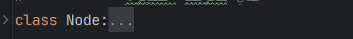
- Linked List: stores products for each drug.
- 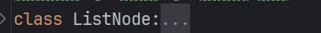
- Each node of the tree has one drug and a list of its products.
Main Functions :

- Add a new drug :
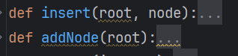
- Search for a drug by ID:
- Add and delete products of Drug:
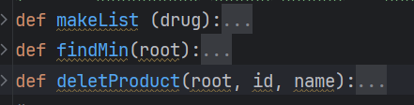
- Show Drugs have the same product by its name
- Replace a product in all drugs By its name:
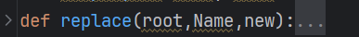
- Delete a drug by ID:
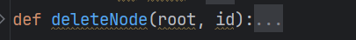
- Show all drugs :
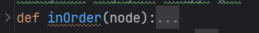

- Modify a drug by id :
- 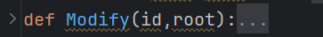

- Upload and update data to a file:
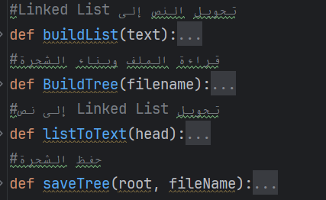
In-Order Traversal :
In-Order Traversal is used to display the drugs stored in the Binary Search Tree. This traversal visits the left subtree, then the current node, and finally the right subtree (Left – Root – Right). It is implemented using recursion.
In-Order is also used when searching and displaying all drugs that contain the same product. By traversing the whole tree, the program checks the product list of each drug and displays only the drugs that have the required product.
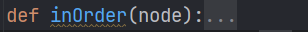

Binary search benefits :

Binary search in a Binary Tree is based on comparison and dividing the data into two parts at each step. Instead of checking all nodes like linear search, we compare the target value with the root. If it is smaller, we go to the left subtree; if it is larger, we go to the right subtree, and we repeat the same process. In this way, half of the elements are ignored at every level.

This greatly reduces the number of comparisons. In a balanced tree, the height is about log2(n): so the time complexity of search becomes O(logn) instead of O(n). The main benefit of binary search in a tree is speed and efficiency, especially when working with a large number of elements.

Algorithms
Insertion, search, modify and deletion in the BST are done using recursion.
The program goes left or right in the tree until it finds the correct place or the wanted drug.

Conclusion
This project shows how BST and Linked Lists can be used to manage pharmacy data. Using recursion makes the code simple and clear. Python helps to build an easy and flexible system.

